PROPOSED SOLUTION
Date | 24 JAN 2026
Team Id | LTVIP2026TMIDS81631
Project name | BOOK NEST: WHERE STORIES NESTLE
marks

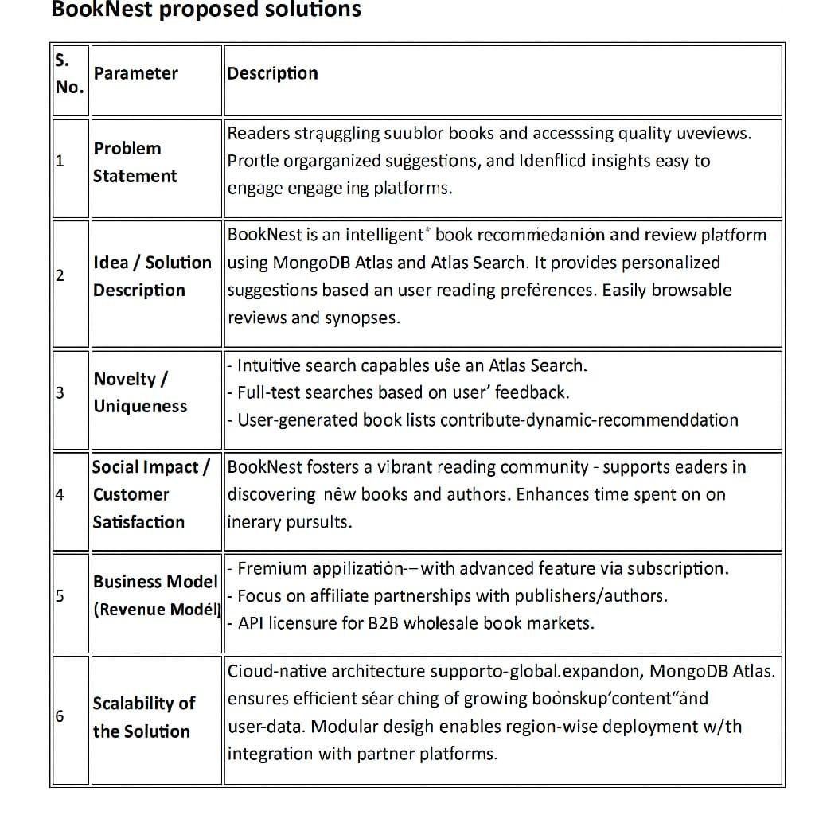

Proposed Solution – BookNest
BookNest is envisioned as an intelligent, interactive, and inclusive online bookstore that solves the modern reader's pain points while empowering authors to reach their audience. The solution merges the personalization of advanced technology with the soul of traditional bookstores to deliver a unique digital reading experience.
Key Elements of the Proposed Solution:

AI-Powered Recommendation System
Utilizes user behavior, preferences, purchase history, and trending genres to provide hyper-personalized book suggestions, helping users discover titles they might not find elsewhere.

Community-Centric Platform
Encourages interaction through reader reviews, ratings, book clubs, discussion forums, and “shelves” that users can share. This social layer builds loyalty and engagement.

Author-Centric Marketplace
Provides indie authors with tools to publish, promote, and monetize their books directly on the platform, bypassing traditional publishing barriers.

Multi-Format Support
Supports books in physical (hardcover/paperback), digital (eBook), and audio (audiobook) formats, catering to various reader preferences.

Seamless Shopping Experience
Features a minimalist, intuitive UI/UX with smart cart, one-click checkout, live inventory status, and wishlist management.

Admin & Analytics Dashboard
Admins can track inventory, manage categories, run promotions, and view real-time sales analytics through a user-friendly backend system.

Secure & Scalable Infrastructure
Hosted on scalable cloud infrastructure (e.g., AWS), integrated with secure payment gateways (Stripe, Razorpay), and protected by authentication and data encryption.

Gamification & Loyalty Programs
Users earn points for purchases, reviews, and referrals, redeemable as discounts or exclusive access to book events and early releases.

